实验上机6：

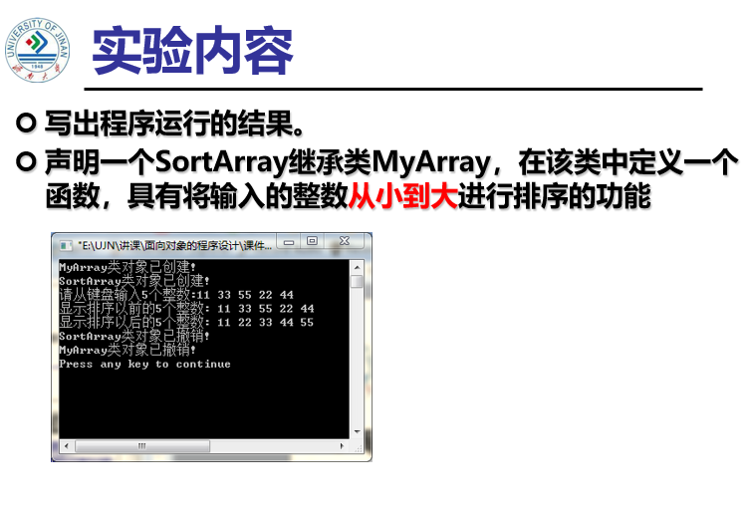

#include<iostream>

#include<string>

using namespace std;

class MyArray {

public:

MyArray(int length);

~MyArray();

void Input();

void Display(string);

protected:

int *alist;

int length;

};

MyArray::MyArray(int leng)

{

if (leng <= 0)

{

cout << "error length";

exit(1);

}

length = leng;

alist = new int[length];

if (alist == NULL)

{

cout << "assign failure";

exit(1);

}

cout << "MyArray类对象已创建!" << endl;

}

MyArray::~MyArray()

{

// delete[] alist;

cout << "MyArray类对象已撤销!" << endl;

}

void MyArray::Display(string str)

{

int i;

int *p = alist;

cout << str << length << "个整数: ";

for (i = 0; i < length; i++, p++)

cout << *p << "";

cout << endl;

}

void MyArray::Input()

{

cout << "请从键盘输入" << length << "个整数:";

int i;

int *p = alist;

for (i = 0; i < length; i++, p++)

cin >> *p;

}

class SortArray :public MyArray

{

public:

SortArray(int leng);

~SortArray();

void paixu();

};

SortArray::SortArray(int leng) :MyArray(leng)

{

if (leng <= 0)

{

cout << "error length";

exit(1);

}

length = leng;

alist = new int[length];

if (alist == NULL)

{

cout << "assign failure";

exit(1);

}

cout << "SortArray类对象已创建!" << endl;

}

SortArray::~SortArray()

{

delete[] alist;

cout << "SortArray类对象已撤销!" << endl;

}

void SortArray::paixu()

{

int i, t, j;

int *p = alist;

for (i = 0; i < length-1; i++)

{

for (j = i+1; j < length; j++)

{

if (alist[i] > alist[j])

{

t = p[i];

p[i] = p[j];

p[j] = t;

}

}

}

cout<<"排序后显示的结果为：" ;

for(i = 0; i < length; i++)

cout << p[i] << " ";

}

int main()

{

// MyArray a(5);

SortArray lei(5);

lei.Input();

lei.paixu();

cout << endl;

return 0;

}

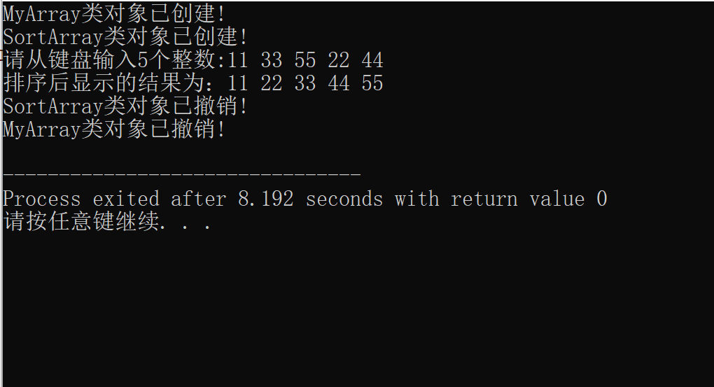

感想心得：

1. 越来越难了，方法只能是多理解多上机操作
2. C++提出了程序继承和派生，提高了编程的效率
3. 可以与现实世界相结合举例理解，更具体形象易懂

**Copyright ©2021-2099 国家乐.All rights reserved**